Homework 7

1.1 Through the window the light blinded me.

|  |  |  |
| --- | --- | --- |
| Word | Number of Senses (Without Part of Speech) | Number of Senses (With Part of Speech) |
| Through | 7 | 2 |
| The | 0 | 0 |
| Window | 8 | 8 |
| The | 0 | 0 |
| Light | 48 | 15 |
| Blinded | 4 | 3 |
| Me | 0 | 0 |
| Combinations: | 10,752 | 720 |

1.2 My journal hides my best kept secrets.

|  |  |  |
| --- | --- | --- |
| Word | Number of Senses (Without Part of Speech) | Number of Senses (With Part of Speech) |
| My | 0 | 0 |
| Journal | 5 | 5 |
| Hides | 6 | 4 |
| My | 0 | 0 |
| Best | 46 | 26 |
| Kept | 23 | 22 |
| Secrets | 3 | 3 |
| Combinations: | 95,220 | 34,320 |

1.3 I hid in the basement.

|  |  |  |
| --- | --- | --- |
| Word | Number of Senses (Without Part of Speech) | Number of Senses (With Part of Speech) |
| I | 0 | 0 |
| Hid | 4 | 4 |
| In | 7 | 1 |
| The | 0 | 0 |
| Basement | 2 | 2 |
| Combinations: | 56 | 8 |

1.4 My reflection stared back at me.

|  |  |  |
| --- | --- | --- |
| Word | Number of Senses (Without Part of Speech) | Number of Senses (With Part of Speech) |
| My | 0 | 0 |
| Reflection | 8 | 8 |
| Stared | 2 | 2 |
| Back | 28 | 6 |
| At | 0 | 0 |
| Me | 0 | 0 |
| Combinations: | 448 | 96 |

1.5 We sat on the bench, tranquil.

|  |  |  |
| --- | --- | --- |
| Word | Number of Senses (Without Part of Speech) | Number of Senses (With Part of Speech) |
| We | 0 | 0 |
| Sat | 11 | 10 |
| On | 5 | 3 |
| The | 0 | 0 |
| Bench | 9 | 7 |
| Tranquil | 2 | 2 |
| Combinations: | 990 | 420 |

2.

|  |  |  |
| --- | --- | --- |
| Original Sentence | Stop Words | Filtered |
| I like to run when the sun is out. | I, to, when, the, is | Like run sun out |
| It is bad to eat right before a run. | It, is, to, before, a | Bad eat right run |
| There is too much sun to eat out | There, is, too, to | Much sun eat out |
| Right now, I would like to eat. | I, would, to | Right now like eat |

2a. w occurs in the same sentence as word vj

|  |  |  |  |  |  |  |  |  |  |
| --- | --- | --- | --- | --- | --- | --- | --- | --- | --- |
| W/V | Like | Run | Sun | Out | Bad | Eat | Right | Much | Now |
| Run | 1 | 0 | 1 | 1 | 1 | 1 | 1 | 0 | 0 |
| Sun | 1 | 1 | 0 | 1 | 1 | 1 | 1 | 1 | 0 |
| Eat | 0 | 1 | 1 | 1 | 1 | 0 | 1 | 1 | 1 |

2b. w occurs before or after word vj.

|  |  |  |  |  |  |  |  |  |  |
| --- | --- | --- | --- | --- | --- | --- | --- | --- | --- |
| W/V | Like | Run | Sun | Out | Bad | Eat | Right | Much | Now |
| Run | 1 | 0 | 1 | 0 | 0 | 0 | 1 | 0 | 0 |
| Sun | 0 | 1 | 0 | 1 | 0 | 1 | 1 | 1 | 0 |
| Eat | 1 | 0 | 1 | 1 | 1 | 0 | 1 | 0 | 0 |

3.

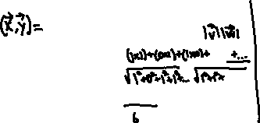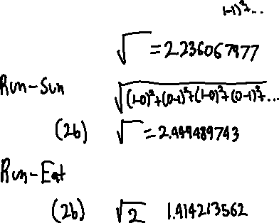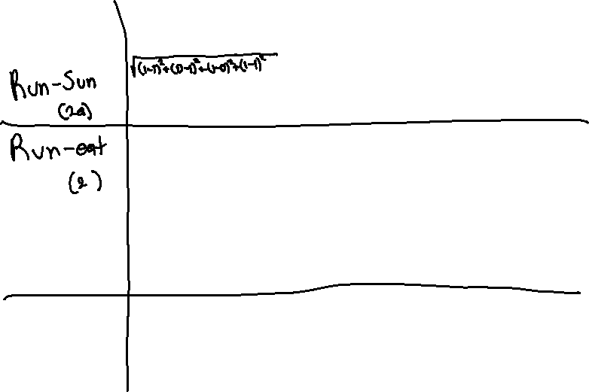

4. The Jaccard method would be the best method, as described by the book, and also represented by the data retrieved from the calculations.